  
make these slide images less blurry …the dimentions of the image is as per you asked so see what you can do

**\*Not possible**  
  
  
make this orange like the slide colour  
  
  
orange like the slide as well  
  
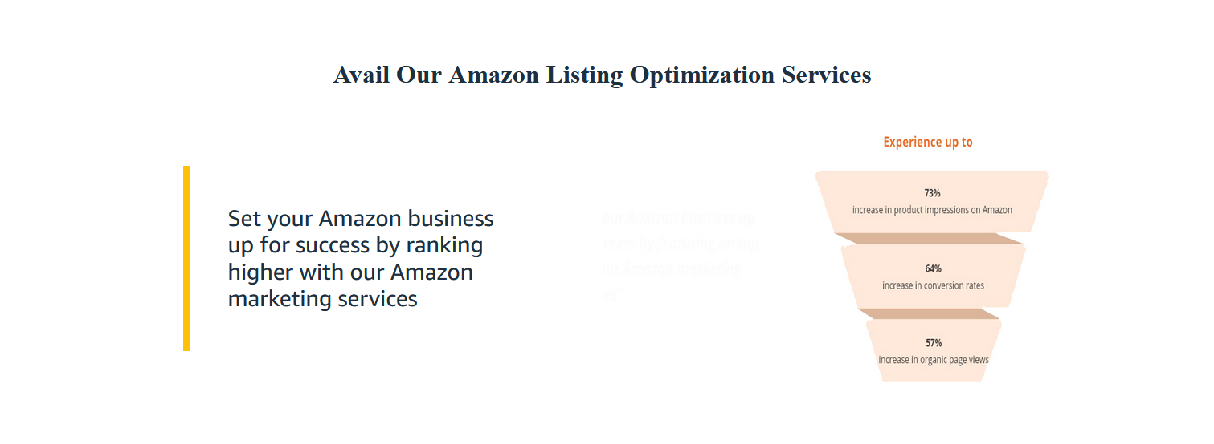  
make this text a bit lengthier so it comes near the image in the right. Centre gap is looking odd

**\*Not possible**  
  
  
the white section “you have a vision” need to be moved above the picture and should be orange  
  
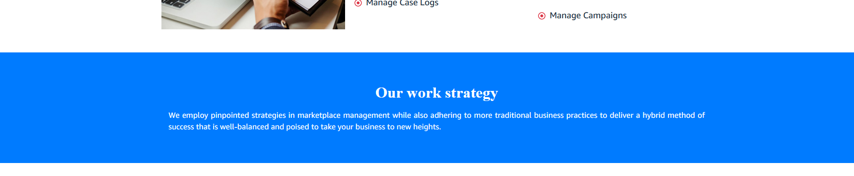  
orange again  
  
  
remove this section  
  
  
orange please  
  
  
make the text paragraph a bit centred on the white part  
  
  
the text alignment ..make it centre (like quote word and the button in the centre of the top line)  
  
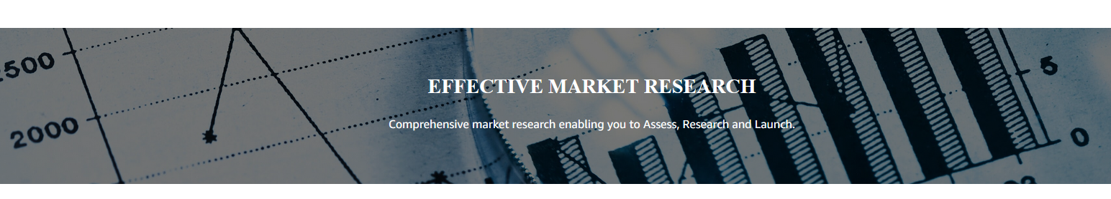  
make it moving image and a bit taller …too narrow

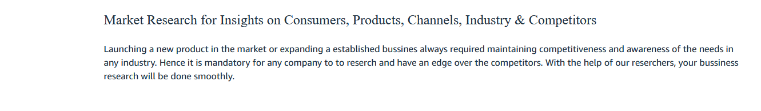  
centred text with headline bold orange  
  
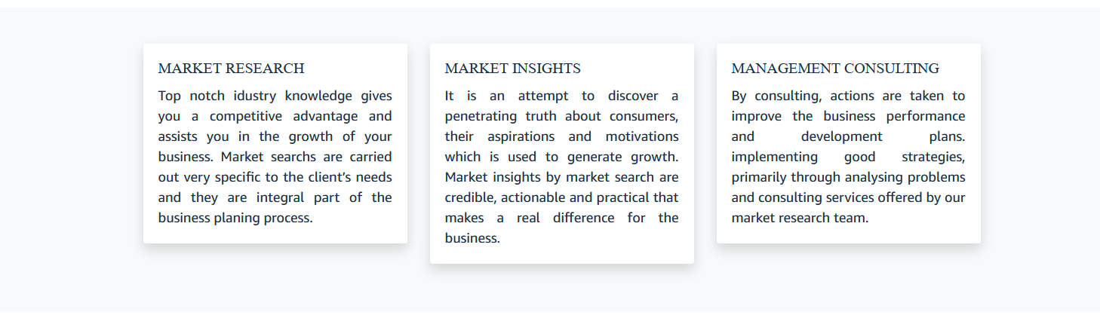  
the space outside the 3 white tiles can have one of the theme colours , see which looks good  
  
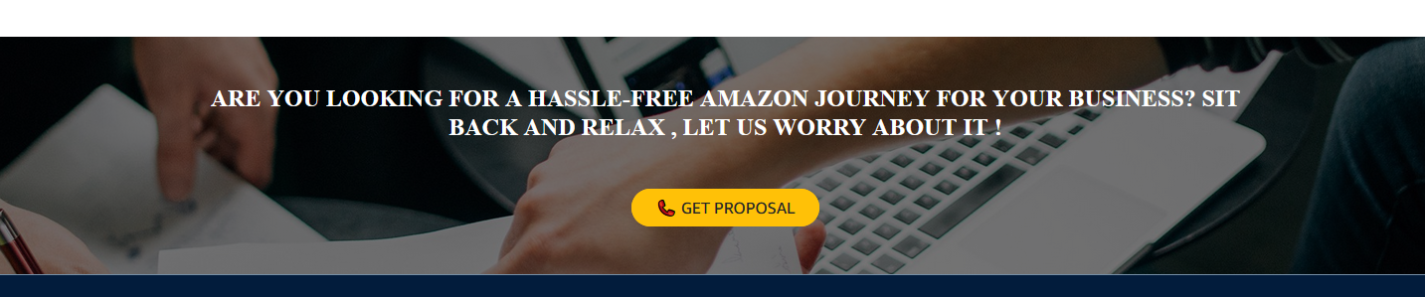  
make this moving image  
  
**\*Not possible**  
  
  
place the image on the right and use the left over white part of the image to put the text  
  
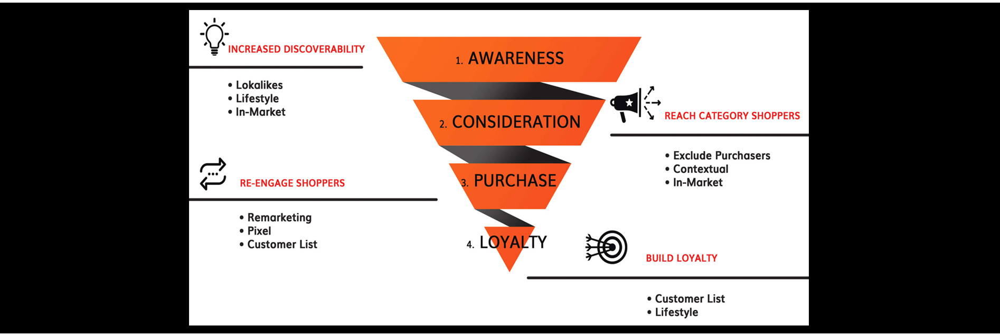  
try removing the black from here ..if needed I will remove the black lines from the image  
  
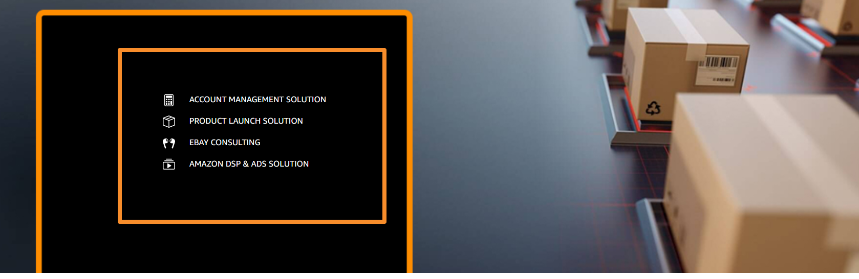

**\*update the background image without the black box**  
I didn’t make a second orange box here …make the text and icons bigger and make it fit the first box ..no need of second box  
  
  
will send a image change here  
**\*Not possible**  
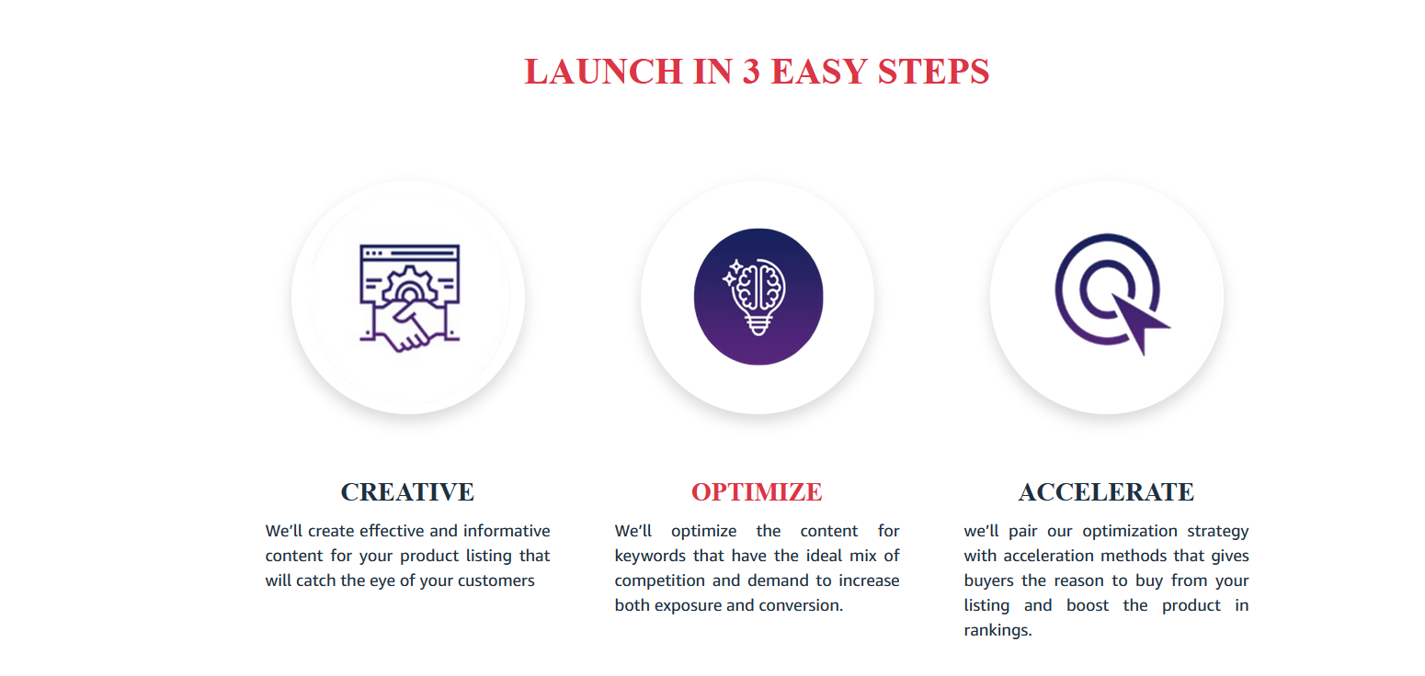  
we don’t have red in theme colour…..i will tune the icons into orange …make the same for the red text ..turn them orange  
  
  
orange in place of blue  
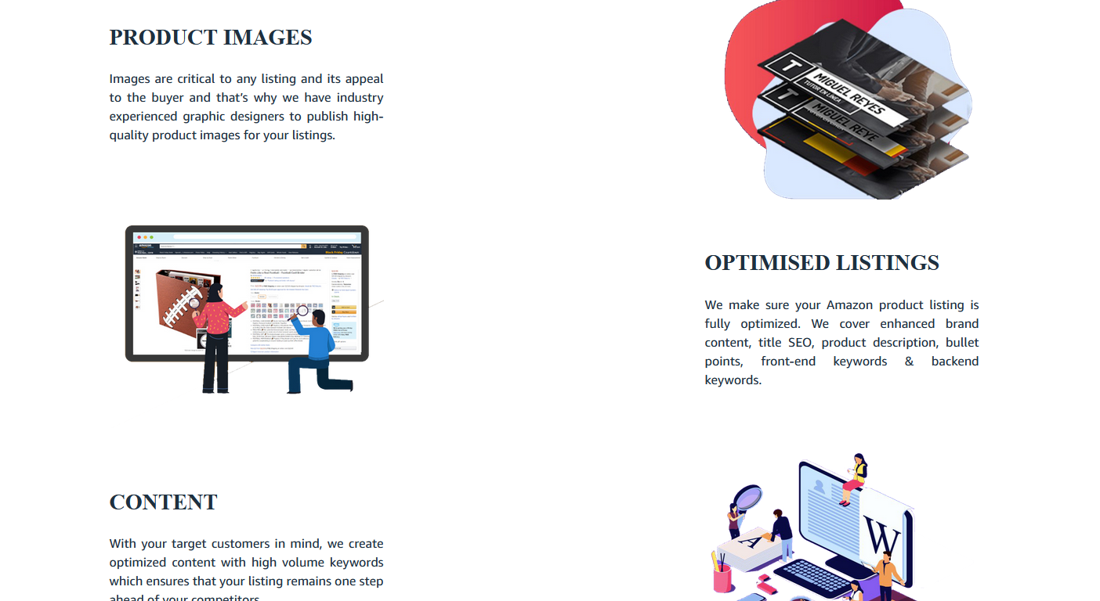  
try to adjust the gaps as minimal as you can  
**\*Not possible for responsivness**  
  
centre the text and button on the white space not left aligned  
  
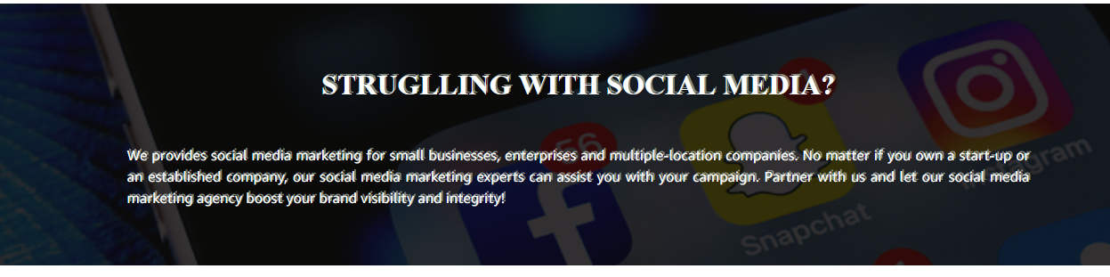  
this text style is not looking good ..blurred   
  
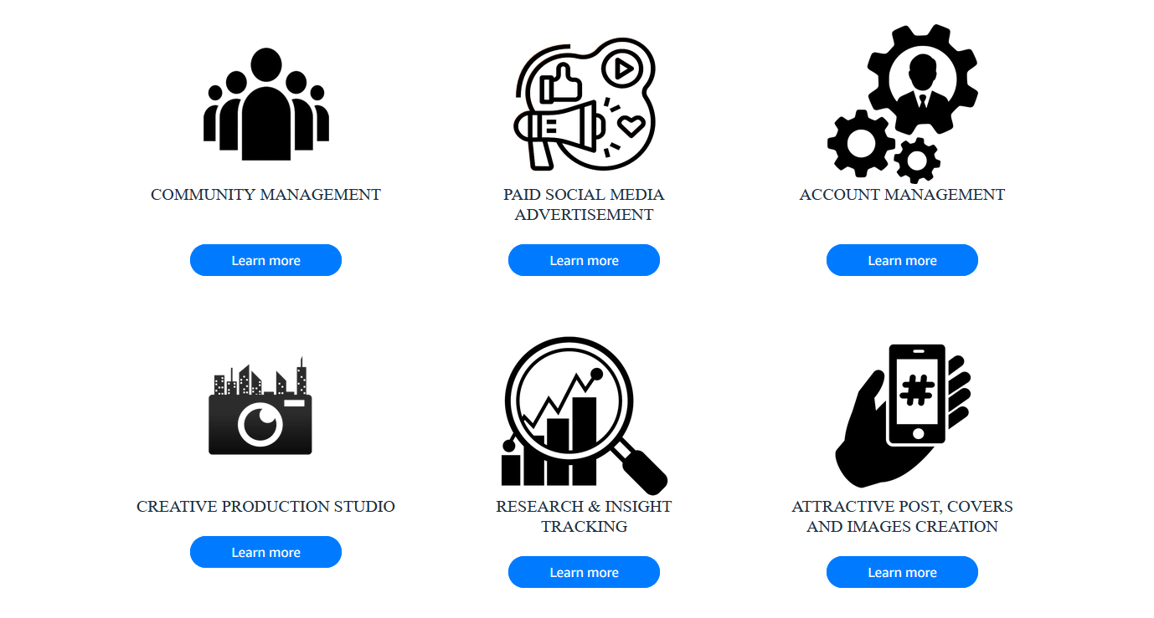  
orange buttons  
  
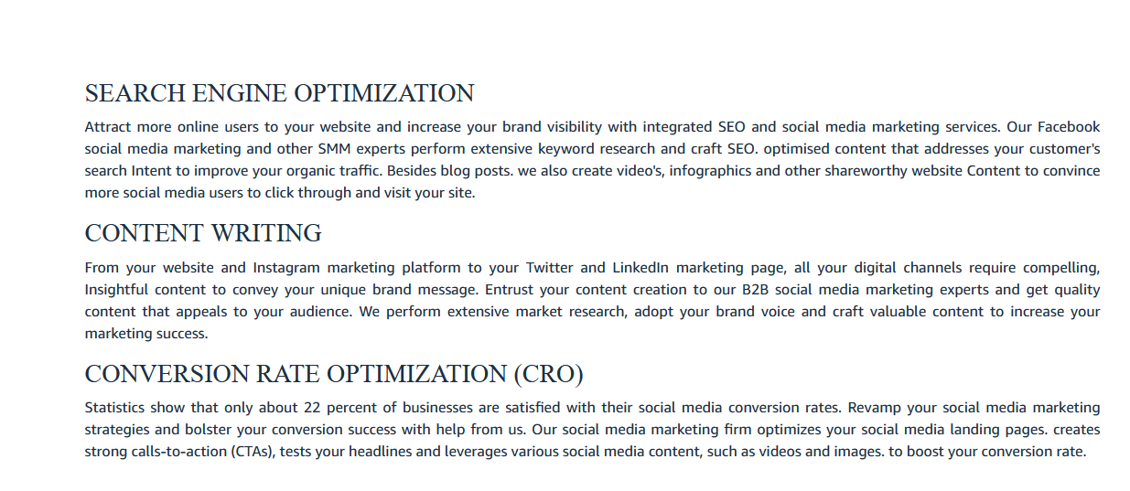  
missed a heading “ why us”  
  
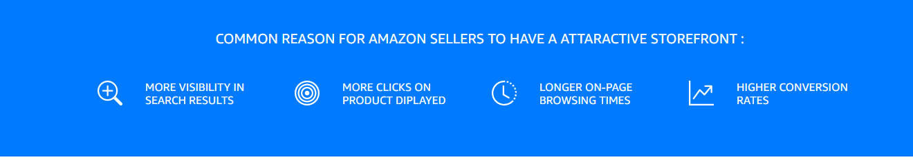  
orange color  
  
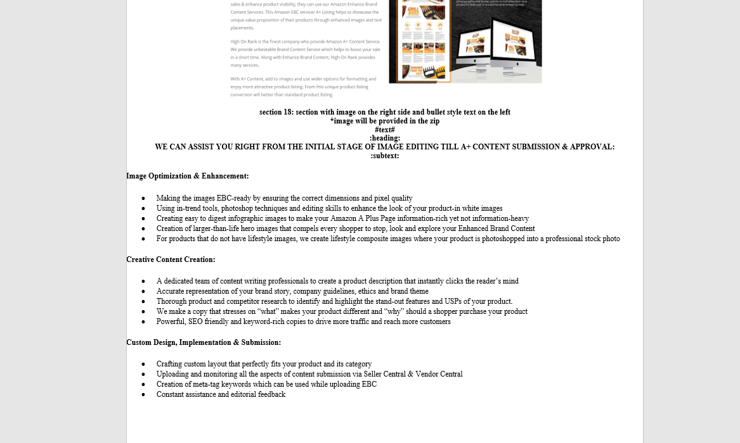  
instruction given  
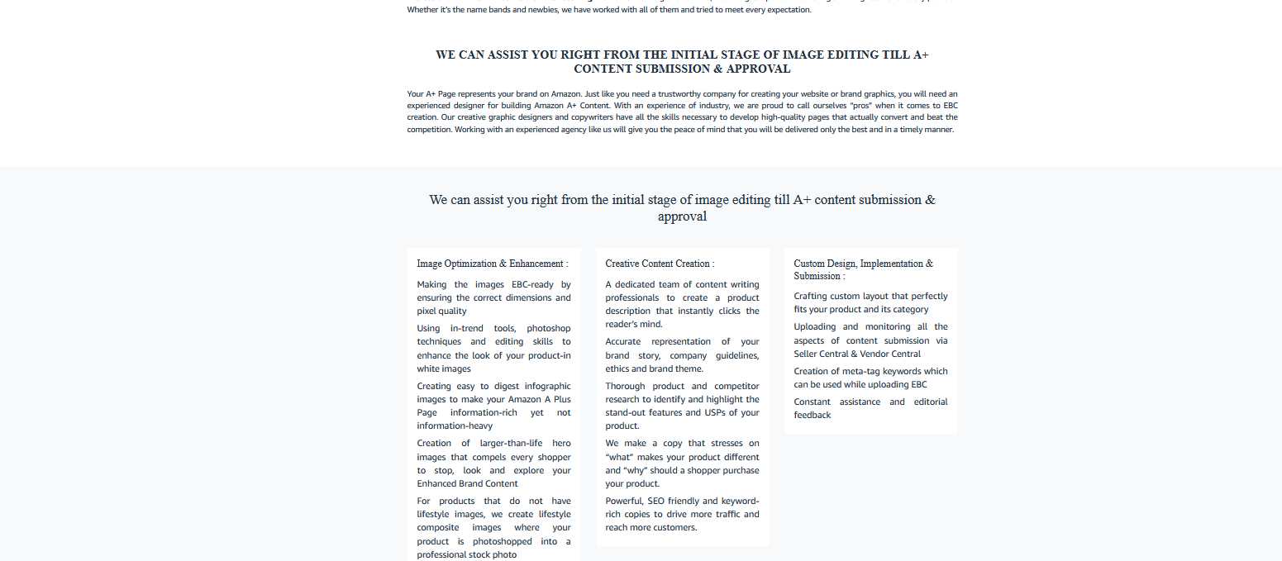  
and this is the website screenshot ….missing the section 18 right side image also. Shouldn’t be tiles  
  
  
make it orange  
  
remove this